List of Navigating Command in Linux
In this table you will find all the navigating command in Linux. So go explore, the tabel and go through the whole article to know the examples.

Use Cases | Description | Examples / Notes
Basic Syntax | cd [directory] | [directory]: Path to navigate to. Defaults to home if omitted.
Navigate to a Specific Directory | cd  /path/to/directory | cd /var/log
Go Back to the Home Directory | cd or cd ~ | cd or cd ~
Navigate to the Previous Directory | cd - | cd - from /var/log returns to  /home/user/Documents
Navigate to the Parent Directory | cd .. | cd .. from  /home/user/Documents moves to /home/user
Use Relative Paths | cd subdirectory | cd Documents moves from  /home/user to  /home/user/Documents
Use Absolute Paths | cd /absolute/path | cd /usr/local/bin

Use Cases | Description | Examples / Notes
Use Tab Completion | Auto-complete directory names | cd /var/l + Tab => cd  /var/log
Check Current Directory | pwd | Prints the full path of your current location.
Handle Spaces in Names | Use quotes or escape spaces | cd "My Documents" or cd My\ Documents
Access Hidden Directories | Include dot in path | cd .config
Directory Not Found | Error: No such file or directory | Ensure correct path.
Insufficient Permissions | Error: Permission denied | Use ls -l for permissions or  sudo.
Navigate to Root Directory | cd / | Navigate to the root directory.
Chain Commands | cd  /path/to/directory && ls | Changes directory and lists contents.
Add Aliases | Create shortcuts in shell config file | alias docs="cd ~/Documents"  and source ~/.bashrc

Syntax of the CD Command in Linux
The 'cd' command allows users to change their current working directory within the file system. The basic syntax of the `cd` command is as follows:

cd [directory]

Here, replace [directory] with the destination directory path you want to navigate to. If no directory is specified, 'cd' will redirect to your home directory by default. Let's explore the command's functionality through examples.

Move Inside a Subdirectory

To move inside a subdirectory in Linux we use the CD Linux Command. Here, replace [directory_name] with the desired directory you want to move in.

cd [directory_name]

For Example: If we want to move to a subdirectory named "Documents"

cd Documents
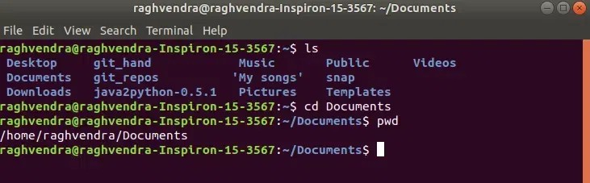

Explanation: Here, we have used the following commands: `ls` = To display all the files and directories in the current
location (directory)
`pwd` = to check the current location path or we can say the current directory name

Using `/` as an Argument

By using `/` as an argument in `cd` we can change the directory to the root directory. The root directory is the first directory in your file system hierarchy.

cd /
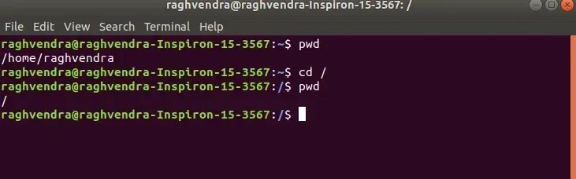

Explanation: Above, / represents the root directory. and used
`pwd` to check the current location path or we can say the current directory name.

Move Inside a Directory From a Directory

This command is used to move inside a directory from a directory. Here, replace "dir_1/dir_2/dir_3" with the subdirectory name or location you want to move in.

cd dir_1/dir_2/dir_3

For Example: We are in the "/home/raghvendra" directory and we want to move to its sub-directory location (path) "Documents/geeksforgeeks/example"

cd Documents/geeksforgeeks/example

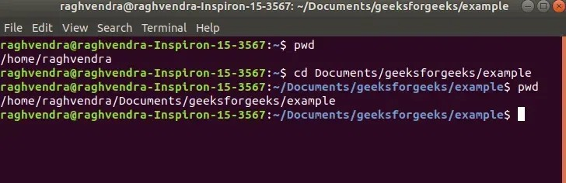

Explanation: We have the document directory and inside the document directory we have a directory named geeksforgeeks and inside that directory, we have an example directory. To navigate the example directory, we have used the command cd Documents/geeksforgeeks/example.

Change Directory to Home Directory From Any Location

`~` This argument is used in the `cd` command to change the directory to the home directory from any location in the Linux System.

cd ~

For Example: We are in location "/home/raghvendra/Documents/geeksforgeeks/example" and want to move to the home directory. We can use the following command.

cd ~
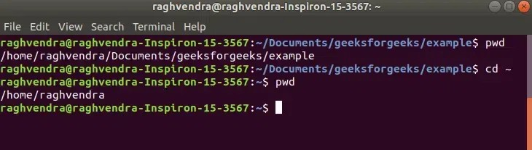
We can also pass the `cd` command with no arguments, which will eventually land us in our home directory.

cd
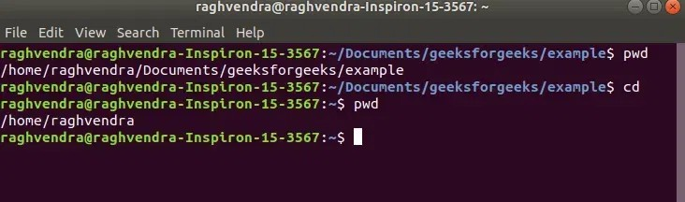

Move to Parent or One Level Up from the Current Directory

We use `..` this as an argument in the `cd` command which is used to move to the parent directory of the current directory, or the directory one level up from the current directory. ".." represents the parent directory.

cd ..

For Example: We are in location "/home/raghvendra/Documents/geeksforgeeks/example" and want to move to the parent or one level up in the directory. We can use the following command.

cd ..
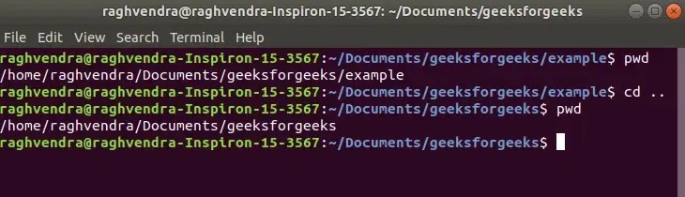

Change Directory by Using DIR NAME Command

This command is used to navigate to a directory with white spaces. Instead of using double quotes, we can use single quotes then also this

command will also work. Here, replace "dir name" with the directory name you want.

cd "dir name"

For Example: If we want to move to "dir name" = "My songs". We use the following command.

cd "My songs"
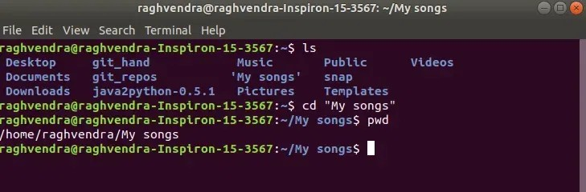
We can also use `\` in between if we don't want to use double or single quotes.

cd My\ songs
